E-com Guidelines AEG
General info
1:1 square format
2000 x 2000 px
Color Profile: sRGB IEC 61966-2-1
Output to EML: TIFF

If there are several color variants most likely for WB or SDA), create layer comp for each color and name them Brand_Project_Benefitname_Colour example: AEG_Fiji_Maneuverability_DenimBlue
Layer comp should have the same name as the output file without extension. This will automatically happen if you use the “Export layer comps” to files script in Photoshop
If there is only 1 color variant, layer comps aren’t needed.)
The layered working file, TIFF or PSD, will then be uploaded to GST SharePoint site.
When creating the briefing import file to EML, fill in the relevant information in column BB and include Media Localizations team in the email.

Font styles and settings general
Typeface: Metric; Kerning: Optical; Leading: Auto; Tracking: 0
Max. reduction in font size -10%. Avoid font size reduction if possible.

E-com Info Graphics
Accessories on the left
Descriptions to the right
Leave white space between particular info blocks, so there is differentiation in what they’re indicating and describing.
No shadows
Background color: pure white R255 G255 B255

Headline: METRIC MEDIUM 20 PT
Body: Metric Light 18 pt
Font color: AEG Carbon R14 G20 B20

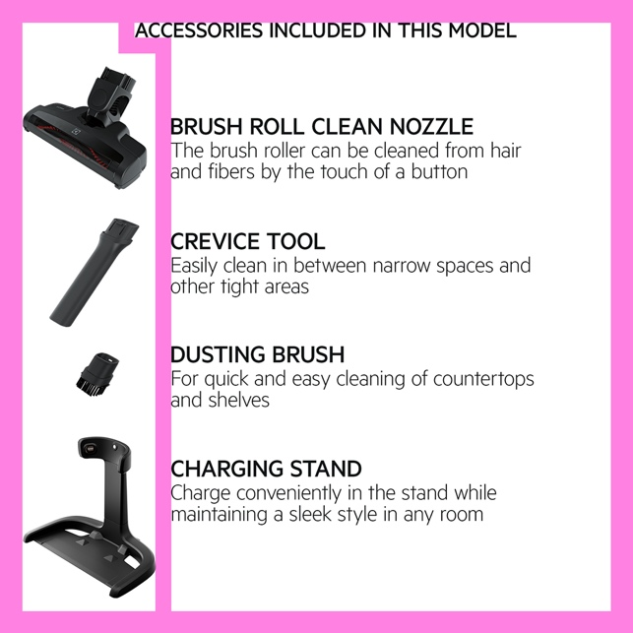

E-com Gallery images
Benefit image with rectangle/ribbon
rectangle size 2000 x 600 px color: AEG Carbon R14 G20 B20
Icon size 327 x 327 px Font color: pure white R255 G255 B255

Header: METRIC MEDIUM 24 PT
Body: Metric Light 20 pt
Disclaimer/ fine print: Metric Light 8 pt
Color: pure white R255 G255 B255

Basic principles for Ecom gallery images
Text elements should be left aligned and centered in the block between top and bottom
Icon placement cannot be modified. Icon is placed 75 pixels from the left side edge and then centered with top and bottom.
Header text lines:
  - Preferred one;
  - Maximum of two.
Body text lines:
  - Preferred two;
  - Maximum of three.
Footnote text lines:
  - Preferred one;
  - Maximum of two.
Good practices:
Avoid font size reduction if possible.
If header was sized down, decrease also body text applying same rule.
This is because we would like to keep stronger emphasis on header.

See below examples and the template for more details.

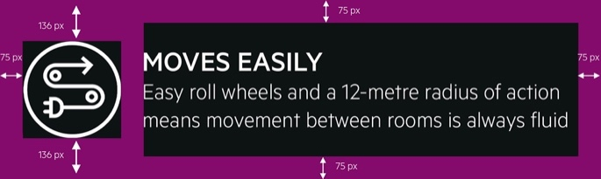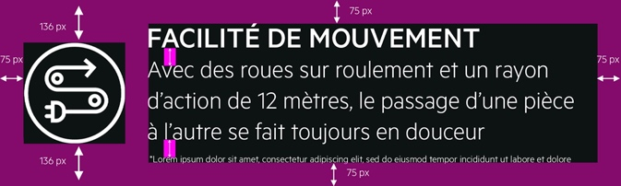

Other important information
- Body copy should only have punctuation in the middle (if separating sentences) and not at the end.

- Text layers and graphics should always be editable.

Modified 29 sep 2022

