**E-com Guidelines AEG**

**General info**

**Aspect ratio: 1:1**

**Size: 2000 x 2000 px**

Color profile: sRGB IEC 61966-2-1

**Output file format to EML: TIFF**

**If there are several color variants most likely for WB or SDA), create layer comp for each color and name them *Brand_Project_Benefitname_Colour* example: AEG_Fiji_Maneuverability_DenimBlue**

**Layer comp should have the same name as the output file without extension. This will automatically happen if you use the “*Export layer comps”* to files script in Photoshop**

**If there is only 1 color variant, layer comps aren’t needed.)**

**The layered working file, TIFF or PSD, will then be uploaded to GST SharePoint site.**

**When creating the briefing import file to EML, fill in the relevant information in column BB and include Media Localizations team in the email.**

**Font styles and settings general**

Typeface: Metric; Kerning: Optical; Leading: Auto; Tracking: 0

Max. reduction in font size -10%. Avoid font size reduction if possible.

**E-com Info Graphics**

**Accessory Infographic**

Accessories with description

Leave white space between particular info blocks, so there is differentiation in what they’re indicating and describing.

No shadows

Background color: pure white R255 G255 B255

Headline: METRIC MEDIUM 83 px

Body: Metric Light 75 px

**Font color:** AEG Carbon R14 G20 B20

**E-com Info Graphics**

**Feature Infographic**

Product in the bottom

Maximum of 6 features

No shadows

Background color: pure white R255 G255 B255

Headline: METRIC MEDIUM 75 px

Body: Metric Light 67 px

Disclaimer/ fine print: Metric Light 33 px

**Font color:** AEG Carbon R14 G20 B20

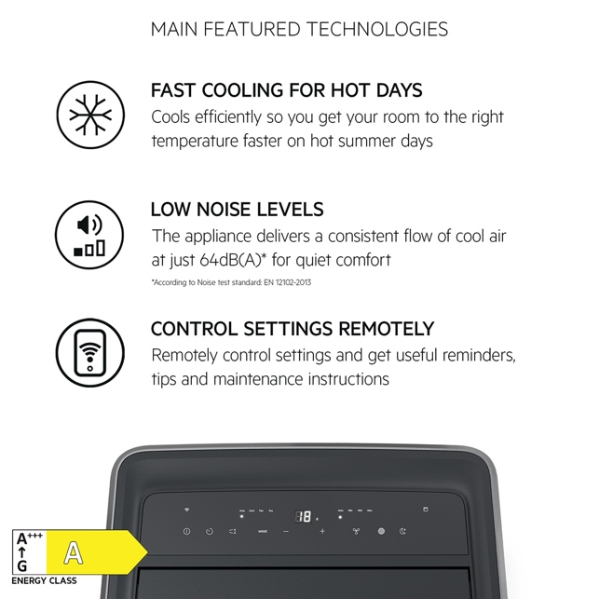

**E-com Gallery images**

**Benefit image with rectangle/ribbon**

**rectangle size 2000 x 600 px** color: AEG Carbon R14 G20 B20

**Icon size 327 x 327 px Font** color: pure white R255 G255 B255

Header: METRIC MEDIUM 100 px

Body: Metric Light 83 px

Disclaimer/ fine print: Metric Light 33 px

Color: pure white R255 G255 B255

**See below examples and the template for more details:**

**Basic principles for Ecom gallery images**

**Text elements should be left aligned and centered in the block** **between top and bottom**

Icon placement cannot be modified. Icon is placed 75 pixels from the left side edge and then centered with top and bottom.

Header text lines:

* + Preferred one;
  + Maximum of two.

Body text lines:

* + Preferred two;
  + Maximum of three.

Footnote text lines:

* + Preferred one;
  + Maximum of two.

Good practices:  
Avoid font size reduction if possible.  
If header was sized down, also decrease body text applying same rule.  
This is because we would like to keep stronger emphasis on header.

**Other important information**

* Body copy should only have punctuation in the middle (if separating sentences) and not at the end.
* Text layers and graphics should always be editable.
* We don’t always need to include an icon; we can create assets without icons if they do not add to conversion. We know from testing they can even take away from conversion if they are too redundant.
* Use supporting icon to add clarity or value to the image and avoid using icons that repeat concepts already shown in the image